**Guide for Indicators**

**SMALL SCALE Projects**

**TAKE NOTE**

**THIS GUIDE IS DESIGNED TO ASSIST POTENTIAL APPLICANTS FOR SMALL SCALE PROJECTS FINANCED BY THE INTERREG VI-A NEXT ROMANIA-UKRAINE PROGRAMME IN SELECTING AND MEASURING CORRECTLY THE PROGRAMME INDICATORS WHILE FILLING IN THE APPLICATION FORM. THE GUIDE IS NOT A STAND ALONE DOCUMENT AND IT SHOULD BE USED TOGETHER WITH THE GUIDELINES FOR GRANT APPLICANTS AND ITS ANNEXES AND JEMS.**

### General INFORMATION

### Definitions

**'Output indicator'** means an indicator to measure the specific deliverables of the intervention. - CPR[1] Article 2

**'Result indicator'** means an indicator to measure the effects of the interventions supported, with particular reference to the direct addressees, population targeted. – CPR Article 2

**'Target'** means a pre-agreed value to be achieved at the end of the eligibility period in relation to an indicator included under a specific objective. - CPR Article 2

**'Milestone'** means an intermediate value to be achieved at a given point in time during the eligibility period in relation to an output indicator included under a specific objective. – CPR Article 2

# ROMANIA – ukraine INTERREG NEXT PROGRAMME STRATEGY AND INTERVENTION LOGIC FOR SMALL SCALE PROJECTS

The Romania-Ukraine Programme finances small scale projects under Priority 2 SO 2.1, and Priority 3, SO3.1. In drafting the applications, the project intervention logic should be linked to the programme intervention logic. This call is for projects on Specific Objectives 2.1 and 3.1.

# Project intervention logic

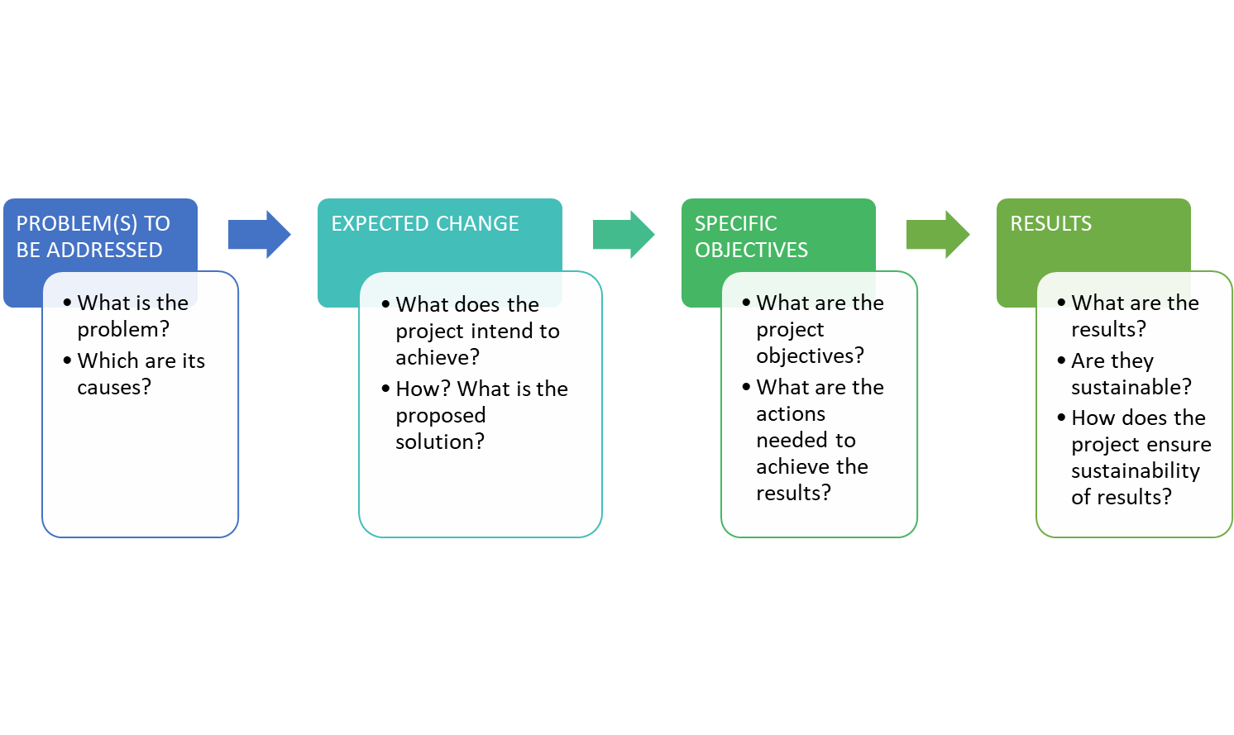

The project intervention logic is described in the graphic above with its main stages. In drafting the application, the most important issue to consider is that the project intervention logic must mirror the programme intervention logic and support its achievement. The graphic below is meant to aid this process.

# Programme- Project Intervention Logic

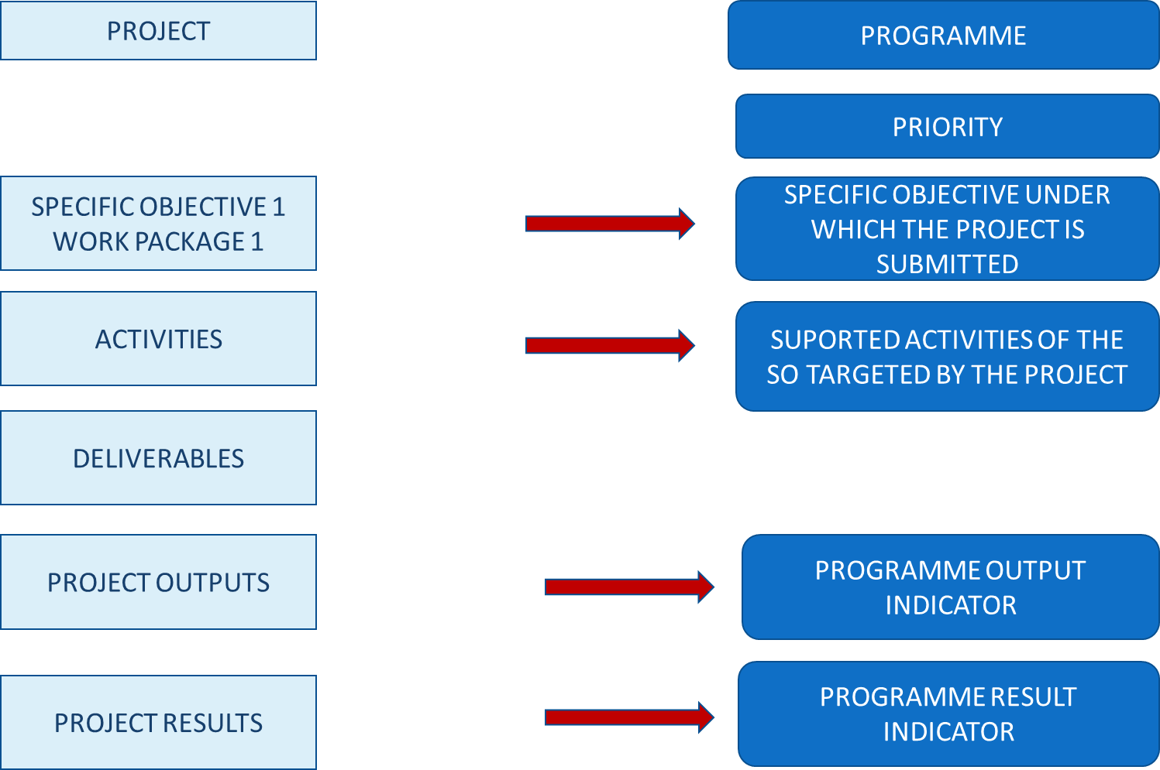

Depending on the Programme Specific Objective under which the project will be submitted, you have to choose the pair/s of output indicators (RCO) and result indicators (RCR/PSR) the project contributes to. For small scale projects the overview of the indicators to be addressed is provided in the table below:

|  |  |  |  |  |
| --- | --- | --- | --- | --- |
| **Priority** | **Specific Objective** | **Output indicators** | **Result indicators** | Mandatory/  recomended |
| 2. Social development across borders | 2.1 Improving equal access to inclusive and quality services in education | RCO 67 - Classroom capacity of new or modernised education facilities | RCR 71 - Annual users of new or modernised education facilities | **recommended** |
| RCO 87 - Organisations cooperating across borders | RCR 84 - Organisations cooperating across borders after project completion | **mandatory** |
| 3. Cooperation across borders | 3.1 Enhance efficient public administration by promoting legal and administrative cooperation and cooperation between citizens, civil society actors and institutions, in particular, with a view to resolving legal, capacity and other obstacles in the border region | RCO 87 - Organisations cooperating across borders | RCR 84 - Organisations cooperating across borders after project completion | **mandatory** |
| RCO 81 - Participations in joint actions across borders | RCR 85 - Participations in joint actions across borders after project completion | **mandatory** |
| RCO 83 - Strategies and action plans jointly developed | RCR 79 - Joint strategies and action plans taken up by organisations | **recommended** |

# General considerations

* One project can address one or more programme output and results indicators. In choosing the indicators that best reflect the objectives and outputs of your project please **take note that some of the indicators are mandatory for small scale projects, as listed above**. **Failing to address them means that the application does not properly contribute to the achievement of the programme’s output and results and will not be selected for financing!**
* Please read carefully the descriptions and guidance notes for each indicator and please note that, for some result indicators, the reporting period could be even one year after project completion;
* In the process of reporting on indicators, the lead partner is the one bearing the responsibility for monitoring and then reporting to the programme structures. In doing this, the lead partner should collect and consolidate partner data against project activities, outputs and results.
* In monitoring and reporting on the achievement of indicators, the lead partner should take the necessary measures in order to avoid double counting and to ensure that there is consistency between the application, implemented activities and reported outputs and results.

# Project Outputs and Results vs Output and Result Indicators

The starting point for the project intervention logic should be the need it aims to fulfill. Leading from this, the activities are generated, the specific deliverables and what the project outputs and results will be. These outputs and results need to be properly described in the application form (Section C4.1 Work Plan and C5 Project results).

Please note that a deliverable is not an output. A deliverable is the documentation of a certain activity (e.g a workshop is a deliverable, while organizations cooperating or people participating in the workshop are outputs and correspond to programme indicators). The deliverables, as presented also in Figure 2 above, don’t have a correspondent in programme intervention logic and are specific to the project.

The outputs are the main “products” of the project and they reflect its most important outcomes. More activities could contribute to the achievement of one output and more than one project output can contribute to the achievement of a programme output indicator.

**TAKE NOTE**

**For each specific objective there are mandatory and recommended indicators. Failing to address the mandatory programme indicators will lead to the rejection of the project proposal!**

# Programme indicators: definitions and guidance

## **PRIORITY 2: SOCIAL DEVELOPMENT ACROSS BORDERS**

## 2.1 Specific objective

### Improving equal access to inclusive and quality services in education, training and lifelong learning through developing accessible infrastructure, including by fostering resilience for distance and on-line education and training

|  |  |  |  |
| --- | --- | --- | --- |
| Specific Objective | Output Indicators | Result Indicators | Mandatory/reccommended |
| *2.1*Improving equal access to inclusive and quality services in education, training and lifelong learning through developing accessible infrastructure, including by fostering resilience for distance and on-line education and training | RCO 87 - Organisations cooperating across borders | RCR 84 - Organisations cooperating across borders after project completion | **Mandatory** |
| RCO 67 - Classroom capacity of new or modernised education facilities | RCR 71 - Annual users of new or modernised education facilities | **Reccommended** |

RCO 87 - Organisations cooperating across borders

This indicator covers all the types of actions proposed under the specific objective 2.1.

The indicator counts the organisations cooperating formally in supported projects. The organisations counted in this indicator are the legal entities (project partners) involved in project implementation. The cooperation should be based on a structured agreement between project participants (Partnership Agreement and/or Cooperation Agreements)). Based on data from previous programming period the percentage of unique entities is of 73% , for simplification purposes for the calculation of indicators a percentage of 70% was taken into consideration

**!** At programme level, double counting should be avoided at the level of project partners and associated organizations!

In addition, double counting will be checked by the programme structures, meaning that at programme level each organization will be counted only once, irrespective the number of projects in which is participanting under the same Specific Objective!

**! The indicator covers all types of activities financed under this specific objective!**

**! Timeframe for measurement: upon project completion!**

**! Double counting should be avoided. The Lead Partner bears the responsibility of reporting correctly on the number of unique organizations cooperating!**

RCR 84 - Organisations cooperating across borders after project completion

The indicator counts the organisations cooperating across borders after the completion of the supported projects. The organisations are the legal entities involved in or benefiting from project implementation, counted within RCO87. The cooperation concept should be interpreted as having a formal agreement to continue cooperation, after the end of the supported project.

A cooperation agreement should be signed during project implementation and the purpose of the project should imply the need for maintaining the cooperation over a longer period of time than the implementation period.

Not all project partners need to continue the cooperation, only one partner from each state is needed.

The timeframe for measurement for the achievement of this indicator will be one year after project completion. Intermediate values can be collected for reporting purposes also during projects implementation.

The sustained cooperation does not have to cover the same topic as addressed by the completed project.

Multiple counting will be removed at the level of the specific objective. An organization is considered once regardless how many times it receives support from operations in the same specific objective. In case the project envisages the conclusion of multiple cooperation agreements, each organisation will be counted by the programme structures only once at the level of the programme, no matter how many cooperation agreements it signs. Therefore, when reporting on this result indicator at project level, the lead partner will mention not only the number of unique organisations that concluded cooperation agreements, but it will also clearly identify these organisations.

RCO67 CLASSROOM CAPACITY OF NEW OR MODERNISED EDUCATION FACILITIES

The indicator covers the following types of activities: • Investments in rehabilitation/modernization/ extension/ equipment procurement for the educational infrastructure to provide the necessary material preconditions of a quality educational process and increase the participation in the educational processes, with a strong focus on accessibility for disabled people; Classroom capacity should be understood in terms of maximum number of pupils/students who can be enrolled in and use the education facilities. Classroom capacity should be calculated in accordance with national legislation, but it should not include teachers, parents, auxiliary personnel or other persons who may use the facilities too The sustained cooperation does not have to cover the same topic as addressed by the completed project.

Multiple counting will be removed at the level of the specific objective. An organization is considered once regardless how many times it receives support from operations in the same specific objective. In case the project envisages the conclusion of multiple cooperation agreements, each organisation will be counted by the programme structures only once at the level of the programme, no matter how many cooperation agreements it signs. Therefore, when reporting on this result indicator at project level, the lead partner will mention not only the number of unique organisations that concluded cooperation agreements, but it will also clearly identify these organisations.

RCR 71 - Annual users of new or modernised education facilities

The indicator counts the annual number of unique registered pupils/ students using the education facility supported. The baseline of the indicator refers to the number of users of the facility supported estimated for the year before the intervention starts, and it is zero for newly built facilities. The purpose of the activities financed through the programme is not necessarily to create additional capacity for existing facilities, but rather to modernize and improve existing ones. Applicants can indicate in the application form the annual number of unique registered pupils/ students using the education facility supported the year before the intervention, at section C 2.1.

!The indicator does not cover teachers, parents, auxiliary personnel or any other persons who may use the facility too!

!The indicator covers existing education facilities

!Virtual users can also be counted if they use the facilities!

!Timeframe for measurement: for achieved values, the calculation should be carried out ex post based on the number and size of groups of pupils/students using the facility at least once during the year after the completion of the intervention!

# **PRIORITY 3: COOPERATION ACROSS BORDERS**

### Specific objective 3.1

### Enhance efficient public administration by promoting legal and administrative cooperation and cooperation between citizens, civil society actors and institutions, in particular, with a view to resolving legal, capacity and other obstacles in the border region:

|  |  |  |  |
| --- | --- | --- | --- |
| Specific Objective | Output Indicator | Result Indicator | Reccommended/ Mandatory |
| 3.1 Enhance efficient public administration by promoting legal and administrative cooperation and cooperation between citizens, civil society actors and institutions, in particular, with a view to resolving legal, capacity and other obstacles in the border region | RCO 87 - Organisations cooperating across borders | RCR 84 - Organisations cooperating across borders after project completion | Mandatory |
| **RCO 81 - Participations in joint actions across borders** | **RCR 85 - Participations in joint actions across borders after project completion** | **Mandatory** |
| RCO 83 - Strategies and action plans jointly developed | RCR 79 - Joint strategies and action plans taken up by organisations | Recommended |

RCO 87 - ORGANISATIONS COOPERATING ACROSS BORDERS

This is an INTERREG specific common output indicator that has been selected to cover all the actions financed under this specific objective. The indicator counts the organisations cooperating formally in supported projects. The organisations counted under this indicator are the legal entities (project partners or associated organisations ) involved in, or benefiting from project implementation. The cooperation should be based on a structured agreement between project participants (such as Partnership Agreement and/or Cooperation Agreements). Based on data from previous programming period the percentage of unique entities is of 73%, for simplification purposes for the calculation of indicators a percentage of 70% was taken into consideration The indicator covers all types of investments!

! Timeframe for measurement: upon project completion! ! At programme level, double counting should be avoided at the level of project partners and associated organizations! In addition, double counting will be checked by the programme structures, meaning that at programme level each organization will be counted only once, irrespective of the specific objective the project is implemented under.

RCR 84 - ORGANISATIONS COOPERATING ACROSS BORDERS AFTER PROJECT COMPLETION

The indicator counts the organisations cooperating across borders after the completion of the supported projects. The organisations are legal entities involved in, or benefiting from project implementation, counted within RCO87. The cooperation concept should be interpreted as having a statement that the entities have a formal agreement to continue cooperation, after the end of the supported project. A cooperation agreement should be signed during project implementation and the purpose of the project should imply the need for maintaining the cooperation over a longer period of time than the implementation period. Not all project partners need to continue the cooperation, only one partner from each state is needed.

The timeframe for measurement for the achievement of this indicator will be during project implementation or one year after project completion. Intermediate values can be collected for reporting purposes also during projects implementation.

The sustained cooperation does not have to cover the same topic as addressed by the completed project.

Multiple counting will be removed at the level of the specific objective. An organization is considered once regardless how many times it receives support from operations in the same specific objective. In case the project envisages the conclusion of multiple cooperation agreements, each organisation will be counted by the programme structures only once at the level of the programme, no matter how many cooperation agreements it signs. Therefore, when reporting on this result indicator at project level, the lead partner will mention not only the number of unique organisations that concluded cooperation agreements, but it will also clearly identify these organisations.

RCO 81 - Participations in joint actions across borders

This output indicator covers the types of actions: joint cross border strategies/action plans/trainings.

The indicator counts the number of participations in joint actions across borders implemented in the supported projects. Participations should be understood as the number of persons attending a joint action across borders - e.g. citizens, volunteers, students, pupils, public officials, etc. and are counted for each joint action organised on the basis of attendance lists or other relevant means of quantification.

**! A joint action is considered as the action organised with the involvement of organizations from both countries (preparation, implementation, etc.).**

**! Participations in public events organized in supported projects will not be counted in this indicator. Participations in events related to project management or other internal project meetings will not be counted under this indicator.**

**! This indicator cannot be used on its own and projects must also contribute to the other output indicator set at the level of the specific objective, namely RCO 83.**

**! Participations, not participants are reported and this will be done based on attendance lists or other relevant means of quantifications. This means that a person can participate in multiple events and the participations will be counted.**

**! This indicator also adds up trainings (but with no certificate of completion or a record confirming the completion of the training).**

RCR 85 - Participations in joint actions across borders after project completion

This result indicator should be selected in relation to the output indicator RCO81 - Participations in joint actions across borders.

In order to measure this change, only data related to RCO - 81 output indicator will feed into the result indicator.

The indicator counts the number of participations in joint actions across borders after the completion of the project, organised by all or some of the former partners or associated organisations within the project, as a continuation of cooperation. Joint actions across borders could include, for instance, exchange activities or exchange visits organized with participants from the two countries of the programme area.

The measurement unit is Participations (i.e. number of persons attending a joint action across border) and should be counted for each joint action organised on the basis of attendance lists or other relevant means of quantification.

! For the definition of this indicator, the joint action includes training schemes!

! Timeframe for measurement: one year after project completion. Intermediate values can be collected for reporting purposes also during projects implementation!

RCO 83 - Strategies and action plans jointly developed

This output indicator covers the types of actions: joint solutions for cross border cooperation; information and awareness campaigns.

The indicator counts the number of joint strategies or action plans developed by supported projects. A jointly developed strategy aims at establishing a targeted way to achieve a goal oriented process in a specific domain. An action plan translates an existing jointly developed strategy into actions.

Jointly developed strategy or action plan implies the involvement of organizations from both countries in the drafting process of the strategy or action plan.

**! If the strategy or action plan covers several specific objectives, it should be counted only for the dominant specific objective!**

**! For a project aiming to implement specific jointly developed strategies or action plans, previously developed, a different output indicator should be used to report on the implementation of action plans!**

RCR 79 - Joint strategies and action plans taken up by organisations

This indicator counts the number of joint strategies and action plans (not individual actions) adopted and implemented by organisations during or after the project completion. At the time of reporting this indicator, the implementation of the joint strategy or action plan need not to be completed but effectively started.

**! The organisations involved in take-up may or may not be direct participants in the supported project!**

It is not necessary that all actions identified are taken-up for a strategy/action plan to be counted in this context.

The value report should be equal to or less than the value for "RCO83 Strategies and action plans jointly developed.

**! If a strategy or action plan covers several specific objectives, it should be counted only for the dominant specific objective!**

**! The measurement of the indicator should be done up to one year after project completion!**

1. REGULATION (EU) 2021/1060 OF THE EUROPEAN PARLIAMENT AND OF THE COUNCIL of 24 June 2021 laying down common provisions on the European Regional Development Fund, the European Social Fund Plus, the Cohesion Fund, the Just Transition Fund and the European Maritime, Fisheries and Aquaculture Fund and financial rules for those and for the Asylum, Migration and Integration Fund, the Internal Security Fund and the Instrument for Financial Support for Border Management and Visa Policy