Guide for Indicators

small scale Projects

TAKE NOTE
THIS GUIDE IS DESIGNED TO ASSIST POTENTIAL APPLICANTS FOR SMALL SCALE PROJECTS FINANCED BY THE INTERREG VI-A NEXT ROMANIA-UKRAINE PROGRAMME IN SELECTING AND MEASURING CORRECTLY THE PROGRAMME INDICATORS WHILE FILLING IN THE APPLICATION FORM. THE GUIDE IS NOT A STAND ALONE DOCUMENT AND IT SHOULD BE USED TOGETHER WITH THE GUIDELINES FOR GRANT APPLICANTS AND ITS ANNEXES AND JEMS.

Table of Contents
1. GENERAL INFORMATION 3
1.1 DEFINITIONS 3
1.2 Romania – ukraine interreg next programme strategy and intervention logic for small scale projects 4
1.3 Project intervention logic 5
1.4 Programme- Project Intervention Logic 6
2. PROGRAMME INDICATORS: DEFINITIONS AND GUIDANCE 10
2.1 General considerations 10
2.2 Project Outputs and Results vs Output and Result Indicators 10
PRIORITY 1: ENVIRONMENTAL FOCUS ACROSS BORDERS 11
Specific objective 1.1: Promoting climate change adaptation and disaster risk prevention and resilience, taking into account eco-system based approaches 11
RCO 87 - Organisations Cooperating Across Borders 12
RCR 84 - Organisations Cooperating Across Borders After Project Completion 12
RCO 83 - Strategies And Action Plans Jointly Developed 13
RCR 79 - Joint Strategies and Action Plans Taken up by Organisations 13
RCO 81 - Participations in Joint Actions Across Borders 14
RCR 85 - Participations in Joint Actions Across Borders after Project Completion 15
RCO 24 - Investments in New or Upgraded Disaster Monitoring, Preparedness, Warning and Response Systems against Natural Disasters 15
PSR 1 - Population Benefiting from Protection Measures against Climate Related Natural Disasters 16
Specific objective 1.2 16
Enhancing protection and preservation of nature biodiversity and green infrastructure, including in urban areas, and reducing all forms of pollution 16
RCO 81 - Participations in Joint Actions across Borders 16
RCR 85 - Participations in Joint Actions Across Borders after Project Completion 18
RCO 83 - Strategies and Action Plans Jointly Developed 18
RCO84 Pilot Actions Developed Jointly and Implemented in Projects 19
RCR 79 - Joint Strategies and Action Plans Taken up by Organisations 19
PRIORITY 2: SOCIAL DEVELOPMENT ACROSS BORDERS 20
Specific objective 2.1 20
Improving equal access to inclusive and quality services in education, training and lifelong learning through developing accessible infrastructure, including by fostering resilience for distance and on-line education and training 20
RCO67 Classroom capacity of new or modernised education facilities 20
RCR 71 Annual users of new or modernised education facilities 20
RCO 87 - Organisations cooperating across borders 21
RCR 84 - Organisations cooperating across borders after project completion 21
Specific objective 2.2: 22
Ensuring equal access to health care and fostering resilience of health systems, including primary care, and promoting the transition from institutional to family-based and community- based care 22
RCO 87 - Organisations cooperating across borders 23
RCR 84 - Organisations cooperating across borders after project completion 23
RCO 69 - Capacity of new or modernised health care facilities 24
RCR 73 - Annual users of new or modernised health care facilities 24
Specific objective 3.1 25
Interreg Specific Objective 2 “A safer and more secure Europe” 25
RCO 81 - Participations in joint actions across borders 25
RCR 85 - Participations in joint actions across borders after project completion 26
RCO 83 - Strategies and action plans jointly developed 26
RCR 79 - Joint strategies and action plans taken up by organisations 27

GENERAL INFORMATION

DEFINITIONS

'Output indicator' means an indicator to measure the specific deliverables of the intervention. - CPR Article 2
'Result indicator' means an indicator to measure the effects of the interventions supported, with particular reference to the direct addressees, population targeted or users of infrastructure. – CPR Article 2

'Target' means a pre-agreed value to be achieved at the end of the eligibility period in relation to an indicator included under a specific objective. - CPR Article 2

'Milestone' means an intermediate value to be achieved at a given point in time during the eligibility period in relation to an output indicator included under a specific objective. – CPR Article 2

Romania – ukraine interreg next programme strategy and intervention logic for small scale projects

The Romania-Ukraine Programme finances small scale projects under all priorities and specific objectives. In drafting the applications the project intervention logic should be linked to the programme intervention logic.

1.3 Project intervention logic
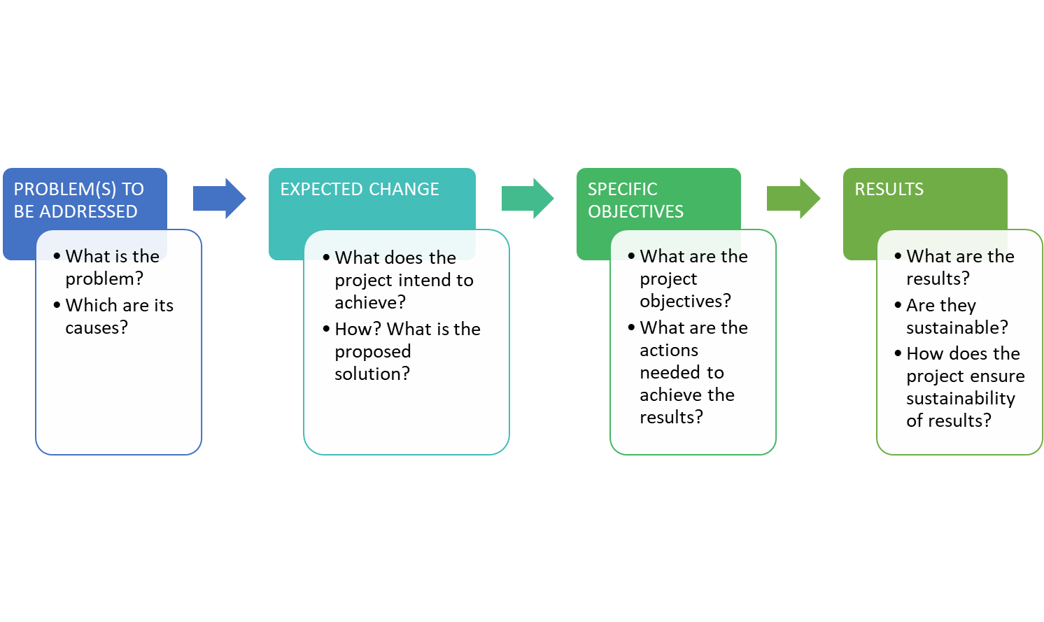
The project intervention logic is described in the graphic above with its main stages. In drafting the application the most important issue to consider is that the project intervention logic must mirror the programme intervention logic and support its achievement. The graphic below is meant to aid this process.

1.4 Programme- Project Intervention Logic

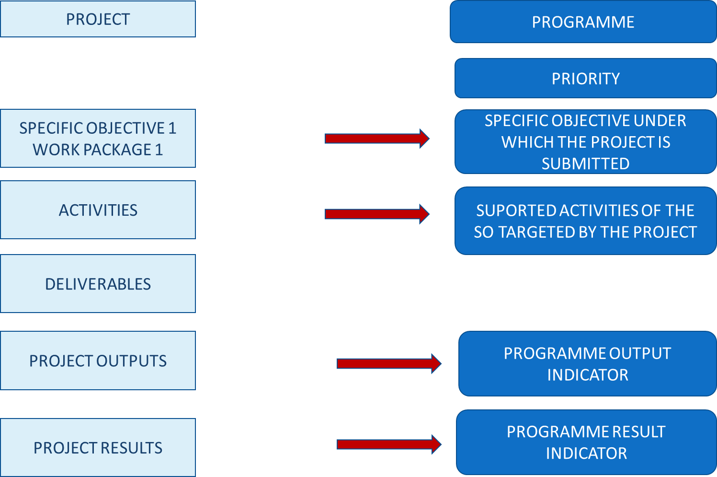

Depending on the Programme Specific Objective under which the project will be submitted, you have to choose the pair/s of output indicators (RCO) and result indicators (RCR/PSR) the project contributes to. For small scale projects the overview of the indicators to be addressed is provided in the table below:

Priority | Specific Objective | Output indicators | Result indicators | Mandatory/  recommended
PRIORITY 1: ENVIRONMENTAL FOCUS ACROSS BORDERS | 1.1 Promoting climate change adaptation and disaster risk prevention and resilience, taking into account eco-system based approaches | RCO 24- Investments in new or upgraded disaster monitoring, preparedness, warning and response systems against natural disasters | PSR1- Population benefiting from protection measures against climate related natural disasters | recommended
 |  | RCO 83: Strategies and action plans jointly developed | RCR79: Joint strategies and action plans taken up by organisations | recommended
 |  | RCO 87 - Organisations cooperating across borders | RCR 84 - Organisations cooperating across borders after project completion | mandatory
 |  | RCO 81 - Participations in joint actions across borders | RCR 85- Participations in joint actions across borders after project completion | recommended
 | 1.2 Enhancing protection and preservation of nature biodiversity and green infrastructure, including in urban areas, and reducing all forms of pollution | RCO 81 - Participations in joint actions across borders | RCR 85- Participations in joint actions across borders after project completion | recommended
 |  | RCO 84 - Pilot actions developed jointly and implemented in projects | RCR79: Joint strategies and action plans taken up by organisations | recommended
 |  | RCO 83: Strategies and action plans jointly developed | RCR79: Joint strategies and action plans taken up by organisations | recommended
PRIORITY 2: SOCIAL DEVELOPMENT ACROSS BORDERS | 2.1 Improving equal access to inclusive and quality services in education, training and lifelong learning through developing accessible infrastructure, including by fostering resilience for distance and on-line education and training | RCO 67 - Classroom capacity of new or modernised education facilities | RCR 71 - Annual users of new or modernised education facilities | recommended
 |  | RCO 87 - Organisations cooperating across borders | RCR 84 - Organisations cooperating across borders after project completion | mandatory
 | 2.2 Ensuring equal access to health care and fostering resilience of health systems, including primary care, and promoting the transition from institutional to family-based and community- based care | RCO 87 - Organisations cooperating across borders | RCR 84 - Organisations cooperating across borders after project completion | mandatory
 |  | RCO 69 Capacity of new or modernised health care facilities | RCR 73 Annual users of new or modernised health care facilities | Recommended
PRIORITY 3: BORDER COOPERATION | 3.1 Border crossing management and mobility | RCO 81 - Participations in joint actions across borders | RCR 85 - Participations in joint actions across borders after project completion | mandatory
 |  | RCO 83 - Strategies and action plans jointly developed | RCR 79 - Joint strategies and action plans taken up by organisations | mandatory

PROGRAMME INDICATORS: DEFINITIONS AND GUIDANCE

2.1 General considerations

- One project can address one or more output and results indicators. In choosing the indicators that best reflect the objectives and outputs of your project please take note that some of the indicators are mandatory, as listed above. Failing to address them means that the application does not properly contribute to the achievement of the programme’s output and results and will not be selected for financing!
- Please read carefully the descriptions and guidance notes for each indicator and please note, that for some result indicators, the reporting period could be even one year after project completion;
- In the process of reporting on indicators, the lead partner is the one bearing the responsibility for monitoring and then reporting to the programme structures. In doing this, the lead partner should collect and consolidate partner data against project activities, outputs and results.
- In monitoring and reporting on the achievement of indicators, the lead partner should take the necessary measures in order to avoid double counting and to ensure that there is consistency between the application, implemented activities and reported outputs and results.

2.2 Project Outputs and Results vs Output and Result Indicators

The starting point for the project intervention logic should be the need it aims to fulfill. Leading from this, the activities are generated, the specific deliverables and what the project outputs and results will be. These outputs and results need to be properly described in the application form (Section C4.1 Work Plan).
Please note that a deliverable is not an output. A deliverable is the documentation of a certain activity (e.g a workshop is a deliverable, while organizations cooperating or people participating in the workshop are outputs and correspond to programme indicators). The deliverables, as presented also in Figure 2 above, don’t have a correspondent in programme intervention logic and are specific to the project.
The outputs are the main “products” of the project and they reflect its most important outcomes. More activities could contribute to the achievement of one output and more than one project output can contribute to the achievement of a programme output indicator.

PRIORITY 1: ENVIRONMENTAL FOCUS ACROSS BORDERS

Specific objective 1.1: Promoting climate change adaptation and disaster risk prevention and resilience, taking into account eco-system based approaches

Specific Objective | Output Indicators | Result Indicators | Mandatory/  Recommended
1.1. Promoting climate change adaptation an disaster risk prevention… | RCO 87 - Organisations cooperating across borders | RCR 84 - Organisations cooperating across borders after project completion | Mandatory
 | RCO 83 - Strategies and action plans jointly developed | RCR 79 - Joint strategies and action plans taken up by organisations | Recommended
 | RCO 81 - Participations in joint actions across borders | RCR 85 - Participations in joint actions across borders after project completion | Recommended
 | RCO 24- Investments in new or upgraded disaster monitoring, preparedness, warning and response systems against natural disasters | PSR 1- Population benefiting from protection measures against climate related natural disasters | Recommended

TAKE NOTE
For Specific Objective 1.1 Promoting climate change adaptation and disaster risk prevention, RCO 87 is mandatory! Failing to address this indicator will lead to the rejection of the project proposal!

RCO 87 - Organisations Cooperating Across Borders
This indicator covers all the types of actions proposed under the specific objective 1.1.
The indicator counts the organisations cooperating formally in supported projects. The organisations counted in this indicator are the legal entities (project partners) involved in project implementation or included in cooperation agreements within the application form. The cooperation should be based on a structured agreement between project participants (such as Partnership Agreement).
! The indicator covers all types of activities financed under this specific objective!
! Timeframe for measurement: upon project completion!
! Double counting should be avoided. The Lead Partner bears the responsibility of reporting correctly on the number of unique organizations cooperating!

RCR 84 - Organisations Cooperating Across Borders After Project Completion
The indicator counts the organisations cooperating across borders after the completion of the supported projects. The organisations are legal entities involved in project implementation, counted within RCO87. The cooperation concept should be interpreted as having a a formal agreement of the entities to continue cooperation, after the end of the supported project.
A cooperation agreement should be signed during project implementation and the purpose of the project should imply the need for maintaining the cooperation over a longer period of time than the implementation period.
Not all project partners need to continue the cooperation, only one partner/organization from each state is needed.
The timeframe for measurement for the achievement of this indicator will be during project implementation or one year after project completion. Intermediate values can be collected for reporting purposes also during projects implementation.
The sustained cooperation does not have to cover the same topic as addressed by the completed project.
Multiple counting will be removed at the level of the specific objective. An organization is considered once regardless how many times it receives support from operations in the same specific objective. In case the project envisages the conclusion of multiple cooperation agreements, each organisation will be counted by the programme structures only once at the level of the programme, no matter how many cooperation agreements it signs. Therefore, when reporting on this result indicator at project level, the lead partner will mention not only the number of unique organisations that concluded cooperation agreements, but it will also clearly identify these organisations.

RCO 83 - Strategies And Action Plans Jointly Developed
This indicator covers the types of actions:
- Common strategies and tools for hazard management and risk prevention including joint action plans, technical and operational measures meant to ensure real-time coordinated actions, risk plans, intervention procedures, exercises, public awareness campaigns, elaborating of updated joint operational plans and procedural framework for efficient management and deployment of joint interventions, hydrological monitoring of rivers, water temperature, precipitation measurements, ice regime.
The indicator counts the number of joint strategies, action plans developed by supported projects. A jointly developed strategy aims at establishing a targeted way to achieve a goal oriented process in a specific domain. An action plan translates an existing jointly developed strategy into actions.
Jointly developed strategy or action plan implies the involvement of organizations from both countries in the drafting process of the strategy or action plan.
If a project includes any of the activities listed above, or similar ones, it should also select this output indicator and its correspondent result indicator.
! If the strategy or action plan covers several specific objectives, it should be counted only for the dominant specific objective!
! For a project aiming to implement specific jointly developed strategies or action plans, previously developed, a different output indicator should be used to report on the implementation of action plans!

RCR 79 - Joint Strategies and Action Plans Taken up by Organisations
This indicator counts the number of joint strategies and action plans (not individual actions) adopted and implemented by organisations during or after the project completion. At the time of reporting this indicator, the implementation of the joint strategy or action plan need not to be completed but effectively started.
! The organisations involved in take-up may or may not be direct participants in the supported project!
It is not necessary that all actions identified are taken-up for a strategy/action plan to be counted in this context.
The value reported should be equal to or less than the value for "RCO83 Strategies and action plans jointly developed.
! If a strategy or action plan covers several specific objectives, it should be counted only for the dominant specific objective!

! The measurement of the indicator should be done one year after project completion!

RCO 81 - Participations in Joint Actions Across Borders
This indicator covers the types of actions:
• Trainings: joint training programmes, joint exercises, networking, exchanging experience and knowledge, including raising awareness in the field of efficient risk prevention and management in the cross-border area; etc
The indicator counts the number of participations in joint actions across borders implemented in the supported projects. Participations should be understood as the number of persons attending a joint action across borders - e.g. citizens, volunteers, students, pupils, professionals, authorities and institutions, public officials, etc. and are counted for each joint action organised on the basis of attendance lists or other relevant means of quantification.
! A joint action is considered as being organised with the involvement of organizations from both countries (preparation, implementation, etc) !
! Participations in public events organized in supported projects will not be reported and counted in this indicator!
! Participations in events related to project management or other internal project meetings will not be reported and counted under this indicator!
! Participations, not participants will be reported and this will be done based on attendance lists or other relevant means of quantifications. This means that a person can participate in multiple events and the participations will be counted!
! Under this indicator trainings can also be reported (but with no certificate of completion or a record confirming the completion of the training)!

RCR 85 - Participations in Joint Actions Across Borders after Project Completion
This result indicator should be selected in relation to the output indicator RCO81 - Participations in joint actions across borders.
In order to measure this change, only data related to RCO - 81 output indicator will feed into the result indicator.
The indicator counts the number of participations in joint actions across borders after the completion of the project, organised by all or some of the former partners/beneficiaries, as a continuation of cooperation. Joint actions across borders could include, for instance, exchange activities or exchange visits organized with participants from the two countries of the programme area.
The measurement unit is Participations (i.e. number of persons attending a joint action across border) and should be counted for each joint action organised on the basis of attendance lists or other relevant means of quantification.
! For the definition of this indicator, the joint action includes training schemes!
! Timeframe for measurement: one year after project completion. Intermediate values can be collected for reporting purposes also during projects implementation!

RCO 24 - Investments in New or Upgraded Disaster Monitoring, Preparedness, Warning and Response Systems against Natural Disasters
The indicator measures the value of investments in projects, as defined in the Guidelines for Grant Applicants. Projects should include the value of the investment they foresee in their project as target value.
Given the specific risk profile of the Programme area, floods and fires are likely to be among the main natural threats affecting the territory, directly associated with climate change. Other risks include coastal erosion and landslides, fires caused by draughts and high temperatures etc.
The indicator is intended to observe progress in respect to carrying out the projected investments in relation to natural disasters.
! Timeline for measuring this indicator is upon completion of output in the supported project!

PSR 1 - Population Benefiting from Protection Measures against Climate Related Natural Disasters
Projects should indicate an estimate of the population to benefit from measures against climate related natural disaster. The final data will be collected from the projects using the electronic monitoring system and the contribution to this indicator’s target will be measured upon completion of output in the supported project.
! Measurement unit for this programme specific result indicator is “persons”. Only population residing in the programme area will be counted for this indicator!

! Timeline for measurement is upon completion of output in the supported project!

Specific objective 1.2

Enhancing protection and preservation of nature biodiversity and green infrastructure, including in urban areas, and reducing all forms of pollution

 | Output Indicators | Result Indicator | Mandatory/  Recommended
1.2. Enhancing protection and preservation of nature biodiversity and green infrastructure, including in urban areas | RCO 81 - Participations in joint actions across borders | RCR 85 - Participations in joint actions across borders after project completion | Recommended
 | RCO 83 - Strategies and action plans jointly developed | RCR 79 - Joint strategies and action plans taken up by organisations | Recommended
 | RCO 84 - Pilot actions developed jointly and implemented in projects |  | Recommended

RCO 81 - Participations in Joint Actions across Borders

This is output indicator covers the types of actions:
- Development of studies, research, common protocols for coordinated implementation on European conventions, joint strategies and plans, trainings and awareness campaigns
The indicator counts the number of participations in joint actions across borders implemented in the supported projects. Participations should be understood as the number of persons attending a joint action across borders - e.g. citizens, volunteers, students, pupils, professionals, authorities and institutions, public officials, etc. and are counted for each joint action organised on the basis of attendance lists or other relevant means of quantification.
! A joint action is considered as being organised with the involvement of organizations from both countries (preparation, implementation, etc) !
! Participations in public events organized in supported projects will not be reported and counted in this indicator!
! Participations in events related to project management or other internal project meetings will not be reported and counted under this indicator!
! Participations, not participants will be reported and this will be done based on attendance lists or other relevant means of quantifications. This means that a person can participate in multiple events and the participations will be counted!
! Under this indicator trainings can also be reported (but with no certificate of completion or a record confirming the completion of the training)!

RCR 85 - Participations in Joint Actions Across Borders after Project Completion
This result indicator should be selected in relation to the output indicator RCO81 - Participations in joint actions across borders.
In order to measure this change, only data related to RCO - 81 output indicator will feed into the result indicator.
The indicator counts the number of participations in joint actions across borders after the completion of the project, organised by all or some of the former partners/beneficiaries, as a continuation of cooperation. Joint actions across borders could include, for instance, exchange activities or exchange visits organized with participants from the two countries of the programme area.
The measurement unit is Participations (i.e. number of persons attending a joint action across border) and should be counted for each joint action organised on the basis of attendance lists or other relevant means of quantification.
! For the definition of this indicator, the joint action includes training schemes!
! An estimate should be included in the target value, the final measurement: one year after project completion. Intermediate values can be collected for reporting purposes also during projects implementation!

RCO 83 - Strategies and Action Plans Jointly Developed

This is common output indicator covers the types of actions:
- Endowment: improving human and technical capacity and modernizing monitoring equipment of protected areas;
- Development of studies, research, common protocols for coordinated implementation of European conventions, joint strategies and plans, trainings and awareness campaigns;
- Assessment, protection and improvement of existing ecosystems (research activities, inventory of resources, protection of endangered species, eradication of invasive species, afforestation etc.);
The indicator counts the number of joint strategies, action plans developed by supported projects. A jointly developed strategy aims at establishing a targeted way to achieve a goal oriented process in a specific domain. An action plan translates an existing jointly developed strategy into actions.
Jointly developed strategy or action plan implies the involvement of organizations from both countries in the drafting process of the strategy or action plan.
If a project includes any of the activities listed above, or similar ones, it should also select this output indicator and its correspondent result indicator.
! If the strategy or action plan covers several specific objectives, it should be reported only for the dominant specific objective!
! For a project aiming to implement specific jointly developed strategies or action plans, previously developed, a different output indicator should be used to report on the implementation of action plans!

RCO84 Pilot Actions Developed Jointly and Implemented in Projects
This output indicator is selected to cover the following types of actions:
- Joint projects for the creation/extension of natural reserves in a transboundary context;
- Urban green infrastructure.
The indicator counts the pilot actions developed jointly and implemented by supported projects. The scope of a jointly developed pilot action could be to test procedures, new instruments, tools, experimentation or the transfer of practices. In order to be counted by this indicator,
- the pilot action needs not only to be developed, but also implemented within the project
and
- the implementation of the pilot action should be finalised by the end of the project.
Jointly developed pilot action implies the involvement of organizations from both participating countries in its implementation.
For the implementation of projects developing and implementing pilot actions at least 50% of the budget will be allocated to investments in infrastructure and/or endowment.
Pilot actions don t cover actions like trainings, meetings, events.

RCR 79 - Joint Strategies and Action Plans Taken up by Organisations

This indicator counts the number of joint strategies and action plans (not individual actions) adopted and implemented by organisations during or after the project completion. At the time of reporting this indicator, the implementation of the joint strategy or action plan need not to be completed but effectively started.
! The organisations involved in take-up may or may not be direct participants in the supported project!
It is not necessary that all actions identified are taken-up for a strategy/action plan to be counted in this context.
The value reported should be equal to or less than the value for "RCO83 Strategies and action plans jointly developed”.
! If a strategy or action plan covers several specific objectives, it should be counted only for the dominant specific objective!
! The measurement of the indicator should be done one year after project completion!

PRIORITY 2: SOCIAL DEVELOPMENT ACROSS BORDERS

Specific objective 2.1

Improving equal access to inclusive and quality services in education, training and lifelong learning through developing accessible infrastructure, including by fostering resilience for distance and on-line education and training

Specific Objective | Output Indicator | Result Indicator | Mandatory/ Recommended
2.1. Improving equal access to education | RCO 67 - Classroom capacity of new or modernised education facilities | RCR 71 - Annual users of new or modernised education facilities | Recommended
 | RCO 87 - Organisations cooperating across borders | RCR 84 - Organisations cooperating across borders after project completion | Mandatory

TAKE NOTE
For Specific Objective 2.1 Improving equal access to education both indicators are mandatory! Failing to address these indicators will lead to the rejection of the project proposal!

RCO67 Classroom capacity of new or modernised education facilities
The indicator covers the following types of activities:
• Investments in rehabilitation/modernization/ extension/ equipment procurement for the educational infrastructure to provide the necessary material preconditions of a quality educational process and increase the participation in the educational processes, with a strong focus on accessibility for disabled people;
The indicator may be addressed by projects with an investment component. Classroom capacity should be understood in terms of maximum number of pupils/students who can be enrolled in and use the education facilities. Classroom capacity should be calculated in accordance with national legislation, but it should not include teachers, parents, auxiliary personnel or other persons who may use the facilities too.
! Modernisation does not include energy rennovation or maintenance and repairs!

RCR 71 Annual users of new or modernised education facilities
The indicator counts the annual number of unique registered pupils/ students using the education facility supported. The baseline of the indicator refers to the number of users of the facility supported estimated for the year before the intervention starts, and it is zero for newly built facilities. The purpose of the activities financed through the programme is not necessarily to create additional capacity for existing facilities, but rather to modernize and improve existing ones. Applicants can indicate in the application form the annual number of unique registered pupils/ students using the education facility supported the year before the intervention, at section C 2.1.
!The indicator does not cover teachers, parents, auxiliary personnel or any other persons who may use the facility too!
!The indicator covers existing education facilities such as schools that are modernised/extended, and modernisation does not include energy renovation or maintenance and repairs!
!Virtual users can also be counted if they use the facilities!
!Timeframe for measurement: for achieved values, the calculation should be carried out ex post based on the number and size of groups of pupils/students using the facility at least once during the year after the completion of the intervention!

RCO 87 - Organisations cooperating across borders
This indicator covers the following actions:
- Investments in hardware and software necessary for the development of digital skills;
- Development of joint educational and learning plans and strategies, training and mentorship programmes;
- Development of partnerships between training and education institutions in order to support joint learning and good practice exchange between teachers’/education professionals from both side of the border;
- Development of joint initiatives that support adult education and training, including mobility programs;
The organisations counted in this indicator are the legal entities (project partners) involved in project implementation or included in cooperation agreements within the application form. The cooperation should be based on a structured agreement between project participants (such as Partnership Agreement).
! Timeframe for measurement: upon project completion!
! Double counting should be avoided. The Lead Partner bears the responsibility of reporting correctly on the number of unique organizations cooperating!

RCR 84 - Organisations cooperating across borders after project completion
The indicator counts the organisations cooperating across borders after the completion of the supported projects. The organisations are the legal entities involved in or benefiting from project implementation, counted within RCO87. The cooperation concept should be interpreted as having a statement that the entities have a formal agreement to continue cooperation, after the end of the supported project.
A cooperation agreement should be signed during project implementation and the purpose of the project should imply the need for maintaining the cooperation over a longer period of time than the implementation period.
Not all project partners need to continue the cooperation, only one partner from each state is needed.
The timeframe for measurement for the achievement of this indicator will be during project implementation or one year after project completion. Intermediate values can be collected for reporting purposes also during projects implementation.
The sustained cooperation does not have to cover the same topic as addressed by the completed project.
Multiple counting will be removed at the level of the specific objective. An organization is considered once regardless how many times it receives support from operations in the same specific objective. In case the project envisages the conclusion of multiple cooperation agreements, each organisation will be counted by the programme structures only once at the level of the programme, no matter how many cooperation agreements it signs. Therefore, when reporting on this result indicator at project level, the lead partner will mention not only the number of unique organisations that concluded cooperation agreements, but it will also clearly identify these organisations.

Specific objective 2.2:

Ensuring equal access to health care and fostering resilience of health systems, including primary care, and promoting the transition from institutional to family-based and community- based care

Specific Objective | Output Indicator | Result Indicator | Recommended/ Mandatory
2.2. Ensuring equal access to healthcare | RCO 87 - Organisations cooperating across borders | RCR 84 - Organisations cooperating across borders after project completion | Mandatory
 | RCO 69-Capacity of new or modernized health care facilities | RCR 73- Annual users of new or modernized health care facilities | Recommended

RCO 87 - Organisations cooperating across borders
This indicator covers all the actions financed under this specific objective.
The indicator counts the organisations cooperating for mally in supported projects. The organisations counted in this indicator are the legal entities (project partners) involved in project implementation or included in cooperation agreements within the application form. The cooperation should be based on a structured agreement between project participants.
! The indicator covers all types of activities financed under this specific objective!
! Timeframe for measurement: upon project completion!
! Double counting should be avoided. The Lead Partner bears the responsibility of reporting correctly on the number of unique organizations cooperating!

RCR 84 - Organisations cooperating across borders after project completion
The indicator counts the organisations cooperating across borders after the completion of the supported projects. The organisations are the legal entities involved in or benefiting from project implementation, counted within RCO87. The cooperation concept should be interpreted as having a statement that the entities have a formal agreement to continue cooperation, after the end of the supported project.
A cooperation agreement should be signed during project implementation and the purpose of the project should imply the need for maintaining the cooperation over a longer period of time than the implementation period.
Not all project partners need to continue the cooperation, only one partner from each state is needed.
The timeframe for measurement for the achievement of this indicator will be during project implementation or one year after project completion. Intermediate values can be collected for reporting purposes also during projects implementation.
The sustained cooperation does not have to cover the same topic as addressed by the completed project.
Multiple counting will be removed at the level of the specific objective. An organization is considered once regardless how many times it receives support from operations in the same specific objective. In case the project envisages the conclusion of multiple cooperation agreements, each organisation will be counted by the programme structures only once at the level of the programme, no matter how many cooperation agreements it signs. Therefore, when reporting on this result indicator at project level, the lead partner will mention not only the number of unique organisations that concluded cooperation agreements, but it will also clearly identify these organisations.

RCO 69 - Capacity of new or modernised health care facilities

This indicator counts the maximum annual number of persons that can be served by the new or modernised health care facility at least once during a period of one year. Healthcare facilities include hospitals, clinics, outpatient care centres, specialized care centres etc.
The indicator will be calculated only in relation to the projects envisaging infrastructure construction, rehabilitation and modernisation and large equipment endowment.
! Modernisation does not include energy renovation or maintenance and repairs.
! Timeframe for measurement: upon project completion!

RCR 73 - Annual users of new or modernised health care facilities

This indicator sums up the number of patients served by the new or modernised health care facility during the year after the completion of the intervention. One individual can be counted more than once if using facilities multiple times. Applicants can indicate in the application form the registered patients served at least once by the health care facility during the year before the intervention, at section C 2.1.
Healthcare facilities include hospitals, clinics, outpatient care centres, specialized care centres etc.
! Timeline for measuring the value of this indicator is one year starting with the time when the new or modernised health care facility becomes operational.

Specific objective 3.1

Interreg Specific Objective 2 “A safer and more secure Europe”

Specific Objective | Output Indicator | Result Indicator | Recommended/ Mandatory
3.1. Border crossing management and mobility | RCO 81 - Participations in joint actions across borders | RCR 85 - Participations in joint actions across borders after project completion | Mandatory
 | RCO 83 - Strategies and action plans jointly developed | RCR 79 - Joint strategies and action plans taken up by organisations | Mandatory

RCO 81 - Participations in joint actions across borders
This common output indicator covers the types of actions: “Joint trainings of police, customs, border police, gendarmerie, other structures involved in border management, exchange of best practices on specific areas of activity (analysis, criminal investigation, organized crime, etc); awareness campaigns related to human trafficking and other issues related to border management and border crossing, etc.
The indicator counts the number of participations in joint actions across borders implemented in the supported projects. Participations should be understood as the number of persons attending a joint action across borders - e.g. proffesionals, etc. and are counted for each joint action organised on the basis of attendance lists or other relevant means of quantification.
! A joint action is considered as the action organised with the involvement of organizations from both countries (preparation, implementation, etc) !
! Participations in public events organized in supported projects will not be reported and counted in this indicator. Participations in events related to project management or other internal project meetings will not be reported and counted under this indicator!
! This indicator cannot be used on its own and projects must also contribute to the other output indicator set at the level of the specific objective, namely RCO 83!
! Participations, not participants are reported and this will be done based on attendance lists or other relevant means of quantification. This means that a person can participate in multiple events and the participations will be counted.
! This indicator also adds up trainings (but with no certificate of completion or a record confirming the completion of the training).

RCR 85 - Participations in joint actions across borders after project completion
The indicator counts the number of participations in joint actions across borders after the completion of the project, organised by all or some of the former partners within the project, as a continuation of cooperation. Joint actions across borders could include, for instance, exchange activities or exchange visits organized with participants from the two countries of the programme area.
The measurement unit is Participations (i.e. number of persons attending a joint action across border) and should be counted for each joint action organised on the basis of attendance lists or other relevant means of quantification.
! For the definition of this indicator, the joint action includes training schemes !
! Timeframe for measurement: one year after project completion. Intermediate values can be collected for reporting purposes also during projects implementation!

RCO 83 - Strategies and action plans jointly developed
This is a common output indicator that covers the types of actions:
“Investments in endowment with specific equipment for the activity of the police/customs/border police/gendarmerie (transport vehicles for the K9 units, video recording equipment, drones, search equipment, hardware and software, training equipment, equipment for forensic and explosives experts, etc)
- Investments in modernization, rehabilitation, renovation, upgrading of police and border crossing infrastructure and related buildings
- Investments in common policies, strategies, common intervention plans and strategies,”.
The indicator counts the number of joint strategies or action plans developed by supported projects. A jointly developed strategy aims at establishing a targeted way to achieve a goal oriented process in a specific domain. An action plan translates an existing jointly developed strategy into actions.
Jointly developed strategy or action plan implies the involvement of organizations from both countries in the drafting process of the strategy or action plan.
! If the strategy or action plan covers several specific objectives, it should be counted only for the dominant specific objective!
! For a project aiming to implement specific jointly developed strategies or action plans, previously developed, a different output indicator should be used to report on the implementation of action plans!

RCR 79 - Joint strategies and action plans taken up by organisations
This indicator counts the number of joint strategies and action plans (not individual actions) adopted and implemented by organisations during or after the project completion. At the time of reporting this indicator, the implementation of the joint strategy or action plan need not to be completed but effectively started.
! The organisations involved in take-up may or may not be direct participants in the supported project!
It is not necessary that all actions identified are taken-up for a strategy/action plan to be counted in this context.
The value reported should be equal to or less than the value for "RCO83 Strategies and action plans jointly developed”
! If a strategy or action plan covers several specific objectives, it should be counted only for the dominant specific objective!

! The measurement of the indicator should be done one year after project completion!

REGULATION (EU) 2021/1060 OF THE EUROPEAN PARLIAMENT AND OF THE COUNCIL of 24 June 2021 laying down common provisions on the European Regional Development Fund, the European Social Fund Plus, the Cohesion Fund, the Just Transition Fund and the European Maritime, Fisheries and Aquaculture Fund and financial rules for those and for the Asylum, Migration and Integration Fund, the Internal Security Fund and the Instrument for Financial Support for Border Management and Visa Policy
Only activities related to Intervention Fields 122 Infrastructure for primary and secondary education and 124 Infrastructure for vocational education and training and adult learning are eligible. Please see the programme documents: https://ro-ua.net/en/programme/documents

