Guide for Indicators

Regular Projects

TAKE NOTE
THIS GUIDE IS DESIGNED TO ASSIST POTENTIAL APPLICANTS FOR REGULAR PROJECTS FINANCED BY THE INTERREG VI-A NEXT ROMANIA-UKRAINE PROGRAMME IN SELECTING AND MEASURING CORRECTLY THE PROGRAMME INDICATORS WHILE FILLING IN THE APPLICATION FORM. THE GUIDE IS NOT A STAND ALONE DOCUMENT AND IT SHOULD BE USED TOGETHER WITH THE GUIDELINES FOR GRANT APPLICANTS AND ITS ANNEXES AND JEMS.

Contents
GENERAL INFORMATION 2
Definitions 2
ROMANIA – UKRAINE INTERREG NEXT PROGRAMME STRATEGY AND INTERVENTION LOGIC FOR REGULAR PROJECTS 3
Project intervention logic 4
Programme- Project Intervention Logic 4
General considerations 7
Project Outputs and Results vs Output and Result Indicators 7
Programme indicators: definitions and guidance 8
PRIORITY 2: SOCIAL DEVELOPMENT ACROSS BORDERS 8
Specific objective 2.1 8
Improving equal access to inclusive and quality services in education, training and lifelong learning through developing accessible infrastructure, including by fostering resilience for distance and on-line education and training 8
RCO67 Classroom capacity of new or modernised education facilities 8
RCR 71 Annual users of new or modernised education facilities 9
RCO 87 - Organisations cooperating across borders 9
RCR 84 - Organisations cooperating across borders after project completion 10
Specific objective 2.2: 11
Ensuring equal access to health care and fostering resilience of health systems, including primary care, and promoting the transition from institutional to family-based and community- based care 11
RCO 87 - Organisations cooperating across borders 11
RCR 84 - Organisations cooperating across borders after project completion 11
RCO 69 - Capacity of new or modernised health care facilities 12
RCR 73 - Annual users of new or modernised health care facilities 12

GENERAL INFORMATION

Definitions

'Output indicator' means an indicator to measure the specific deliverables of the intervention. - CPR Article 2
'Result indicator' means an indicator to measure the effects of the interventions supported, with particular reference to the direct addressees, population targeted or users of infrastructure. – CPR Article 2

'Target' means a pre-agreed value to be achieved at the end of the eligibility period in relation to an indicator included under a specific objective. - CPR Article 2

'Milestone' means an intermediate value to be achieved at a given point in time during the eligibility period in relation to an output indicator included under a specific objective. – CPR Article 2
‘Regular projects’ are projects, with an investment component of minimum 500,000 EUR.
‘Investment’ means works and/ or specialised equipment and endowments, as well as services directly linked to the investment (Eg: technical documentation, services for their proper functioning, etc.), which contribute to the project objectives that shall remain in use after the project implementation for at least 5 years after the final payment to the project.

ROMANIA – UKRAINE INTERREG NEXT PROGRAMME STRATEGY AND INTERVENTION LOGIC FOR REGULAR PROJECTS

The Romania-Ukraine Programme finances regular projects under Priority 2 SO 2.1 and SO 2.2. In drafting the applications the project intervention logic should be linked to the programme intervention logic.

Project intervention logic
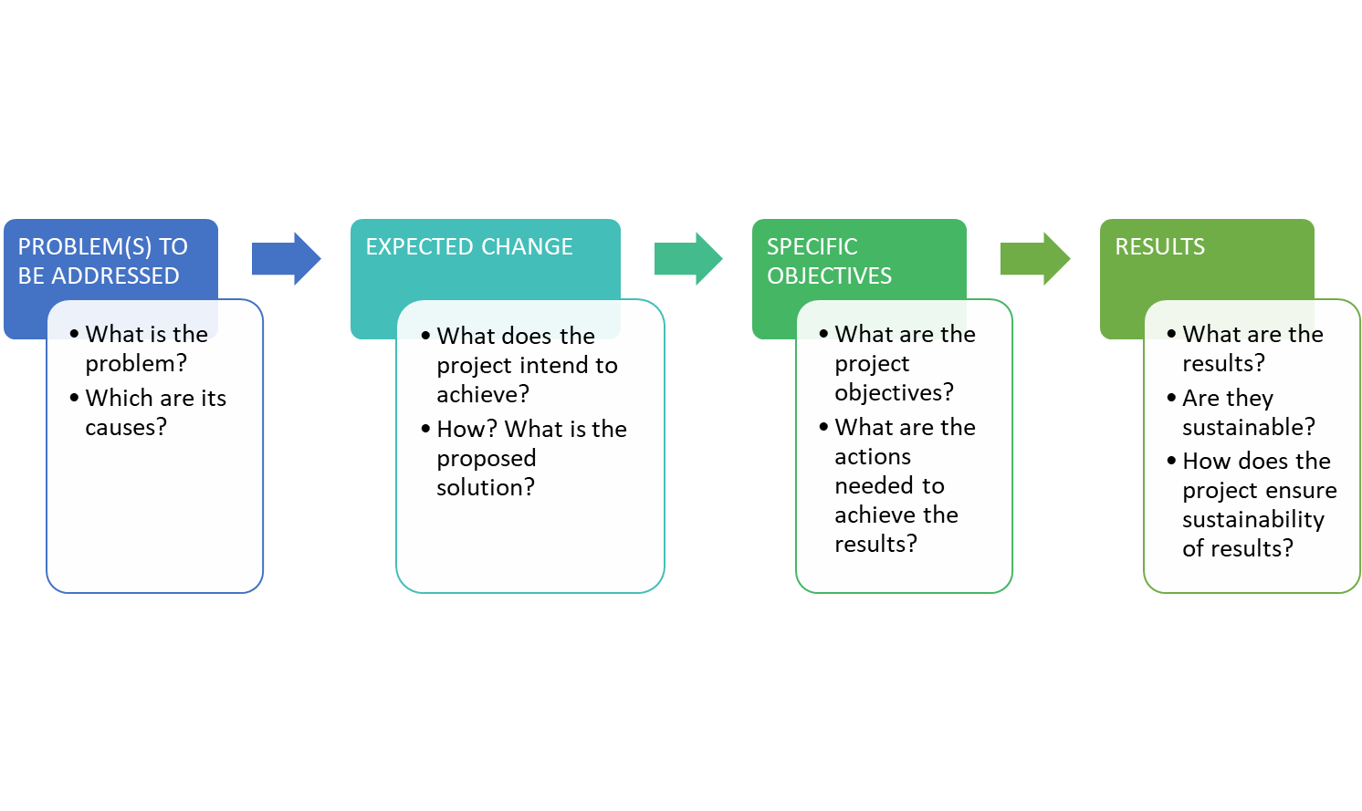
The project intervention logic is described in the graphic above with its main stages. In drafting the application the most important issue to consider is that the project intervention logic must mirror the programme intervention logic and support its achievement. The graphic below is meant to aid this process.

Programme- Project Intervention Logic

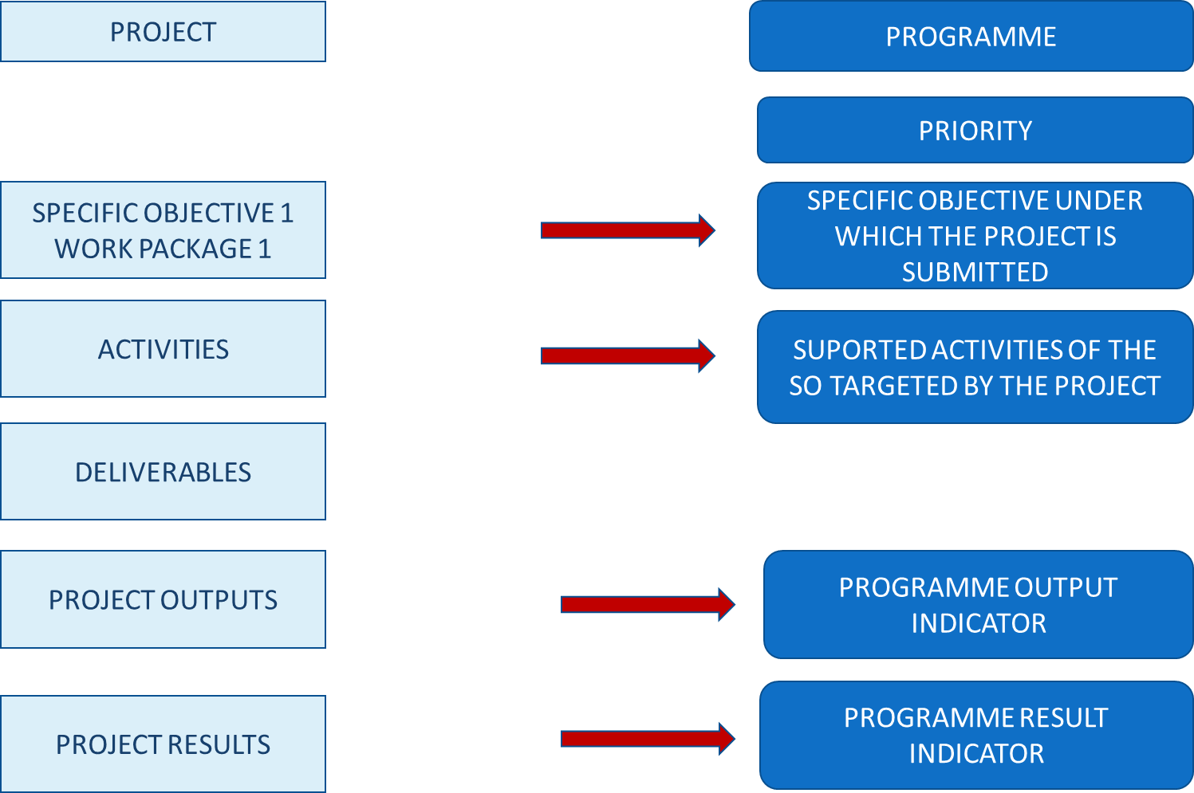

Depending on the Programme Specific Objective under which the project will be submitted, you have to choose the pair/s of output indicators (RCO) and result indicators (RCR/PSR) the project contributes to. For regular projects the overview of the indicators to be addressed is provided in the table below:

Priority | Specific Objective | Output indicators | Result indicators | Mandatory/  recomended
PRIORITY 2: SOCIAL DEVELOPMENT ACROSS BORDERS | (ii) Improving equal access to inclusive and quality services in education, training and lifelong learning through developing accessible infrastructure, including by fostering resilience for distance and on-line education and training | RCO 67 - Classroom capacity of new or modernised education facilities | RCR 71 - Annual users of new or modernised education facilities | mandatory
 |  | RCO 87 - Organisations cooperating across borders | RCR 84 - Organisations cooperating across borders after project completion | mandatory
 | (v) Ensuring equal access to health care and fostering resilience of health systems, including primary care, and promoting the transition from institutional to family-based and community- based care | RCO 87 - Organisations cooperating across borders | RCR 84 - Organisations cooperating across borders after project completion | mandatory
 |  | RCO 69 Capacity of new or modernised health care facilities | RCR 73 Annual users of new or modernised health care facilities | mandatory

General considerations

- One project can address one or more output and results indicators. In choosing the indicators that best reflect the objectives and outputs of your project please take note that some of the indicators are mandatory for regular projects, as listed above. Failing to address them means that the application does not properly contribute to the achievement of the programme’s output and results and will not be selected for financing!
- Please read carefully the descriptions and guidance notes for each indicator and please note, that for some result indicators, the reporting period could be even one year after project completion;
- In the process of reporting on indicators, the lead partner is the one bearing the responsibility for monitoring and then reporting to the programme structures. In doing this, the lead partner should collect and consolidate partner data against project activities, outputs and results.
- In monitoring and reporting on the achievement of indicators, the lead partner should take the necessary measures in order to avoid double counting and to ensure that there is consistency between the application, implemented activities and reported outputs and results.

Project Outputs and Results vs Output and Result Indicators

The starting point for the project intervention logic should be the need it aims to fulfill. Leading from this, the activities are generated, the specific deliverables and what the project outputs and results will be. These outputs and results need to be properly described in the application form (Section C4.1 Work Plan).
Please note that a deliverable is not an output. A deliverable is the documentation of a certain activity (e.g a workshop is a deliverable, while organizations cooperating or people participating in the workshop are outputs and correspond to programme indicators). The deliverables, as presented also in Figure 2 above, don’t have a correspondent in programme intervention logic and are specific to the project.
The outputs are the main “products” of the project and they reflect its most important outcomes. More activities could contribute to the achievement of one output and more than one project output can contribute to the achievement of a programme output indicator.

Programme indicators: definitions and guidance

PRIORITY 2: SOCIAL DEVELOPMENT ACROSS BORDERS

Specific objective 2.1

Improving equal access to inclusive and quality services in education, training and lifelong learning through developing accessible infrastructure, including by fostering resilience for distance and on-line education and training

Specific Objective | Output Indicator | Result Indicator | Mandatory/ reccommended
2.1. Improving equal access to education | RCO 67 - Classroom capacity of new or modernised education facilities | RCR 71 - Annual users of new or modernised education facilities | Mandatory
 | RCO 87 - Organisations cooperating across borders | RCR 84 - Organisations cooperating across borders after project completion | Mandatory

TAKE NOTE
For Specific Objective 2.1 Improving equal access to education both indicators are mandatory! Failing to address these indicators will lead to the rejection of the project proposal!

RCO67 Classroom capacity of new or modernised education facilities
The indicator covers the following types of activities:
• Investments in rehabilitation/modernization/ extension/ equipment procurement for the educational infrastructure to provide the necessary material preconditions of a quality educational process and increase the participation in the educational processes, with a strong focus on accessibility for disabled people;
Classroom capacity should be understood in terms of maximum number of pupils/students who can be enrolled in and use the education facilities. Classroom capacity should be calculated in accordance with national legislation, but it should not include teachers, parents, auxiliary personnel or other persons who may use the facilities too.
! Modernisation does not include energy rennovation or maintenance and repairs!

RCR 71 Annual users of new or modernised education facilities
The indicator counts the annual number of unique registered pupils/ students using the education facility supported. The purpose of the activities financed through the programme is not necessarily to create additional capacity for existing facilities, but rather to modernize and improve existing ones.
!The indicator does not cover teachers, parents, auxiliary personnel or any other persons who may use the facility too!
!The indicator covers existing education facilities such as schools that are modernised/extended, and modernisation does not include energy renovation or maintenance and repairs!
!Virtual users can also be counted if they use the facilities!
!Timeframe for measurement: for achieved values, the calculation should be carried out ex post based on the number and size of groups of pupils/students using the facility at least once during the year after the completion of the intervention! The project should indicate the target aimed to be achieved.

RCO 87 - Organisations cooperating across borders
This indicator covers the following actions:
- Investments in hardware and software necessary for the development of digital skills;
- Development of joint educational and learning plans and strategies, training and mentorship programmes;
- Development of partnerships between training and education institutions in order to support joint learning and good practice exchange between teachers’/education professionals from both side of the border;
- Development of joint initiatives that support adult education and training, including mobility programs;
The organisations counted in this indicator are the legal entities (project partners) involved in project implementation or included in cooperation agreements within the application form. The cooperation should be based on a structured agreement between project participants (such as Partnership Agreement).
! Timeframe for measurement: upon project completion!

RCR 84 - Organisations cooperating across borders after project completion
The indicator counts the organisations cooperating across borders after the completion of the supported projects. The organisations are the legal entities involved in, or benefiting from project implementation, counted within RCO87. The cooperation concept should be interpreted as having a statement that the entities have a formal agreement to continue cooperation, after the end of the supported project.
A cooperation agreement should be signed during project implementation and the purpose of the project should imply the need for maintaining the cooperation over a longer period of time than the implementation period.
Not all project partners need to continue the cooperation, only one partner from each state is needed.
The timeframe for measurement for the achievement of this indicator will be during project implementation or one year after project completion. Intermediate values can be collected for reporting purposes also during projects implementation.
The sustained cooperation does not have to cover the same topic as addressed by the completed project.
Multiple counting will be removed at the level of the specific objective. An organization is considered once regardless how many times it receives support from operations in the same specific objective. In case the project envisages the conclusion of multiple cooperation agreements, each organisation will be counted by the programme structures only once at the level of the programme, no matter how many cooperation agreements it signs. Therefore, when reporting on this result indicator at project level, the lead partner will mention not only the number of unique organisations that concluded cooperation agreements, but it will also clearly identify these organisations.

Specific objective 2.2:

Ensuring equal access to health care and fostering resilience of health systems, including primary care, and promoting the transition from institutional to family-based and community- based care

Specific Objective | Output Indicator | Result Indicator | Reccommended/ Mandatory
2.2. Ensuring equal access to healthcare | RCO 87 - Organisations cooperating across borders | RCR 84 - Organisations cooperating across borders after project completion | Mandatory
 | RCO 69-Capacity of new or modernized health care facilities | RCR 73- Annual users of new or modernized health care facilities | Mandatory

RCO 87 - Organisations cooperating across borders
This indicator covers all the actions financed under this specific objective.
The indicator counts the organisations cooperating formally in supported projects. The organisations counted in this indicator are the legal entities (project partners) involved in project implementation or included in cooperation agreements within the application form. The cooperation should be based on a structured agreement between project participants.
! The indicator covers all types of activities financed under this specific objective!
! Timeframe for measurement: upon project completion!
! Double counting should be avoided. The Lead Partner bears the responsibility of reporting correctly on the number of unique organizations cooperating!

RCR 84 - Organisations cooperating across borders after project completion
The indicator counts the organisations cooperating across borders after the completion of the supported projects. The organisations are the legal entities involved in or benefiting from project implementation, counted within RCO87. The cooperation concept should be interpreted as having a statement that the entities have a formal agreement to continue cooperation, after the end of the supported project.
A cooperation agreement should be signed during project implementation and the purpose of the project should imply the need for maintaining the cooperation over a longer period of time than the implementation period.
Not all project partners need to continue the cooperation, only one partner from each state is needed.
The timeframe for measurement for the achievement of this indicator will be during project implementation or one year after project completion. Intermediate values can be collected for reporting purposes also during projects implementation.
The sustained cooperation does not have to cover the same topic as addressed by the completed project.
Multiple counting will be removed at the level of the specific objective. An organization is considered once regardless how many times it receives support from operations in the same specific objective. In case the project envisages the conclusion of multiple cooperation agreements, each organisation will be counted by the programme structures only once at the level of the programme, no matter how many cooperation agreements it signs. Therefore, when reporting on this result indicator at project level, the lead partner will mention not only the number of unique organisations that concluded cooperation agreements, but it will also clearly identify these organisations.

RCO 69 - Capacity of new or modernised health care facilities

This indicator counts the maximum annual number of persons that can be served by the new or modernised health care facility at least once during a period of one year. Healthcare facilities include hospitals, clinics, outpatient care centres, specialized care centres etc.
The indicator will be calculated only in relation to the regular projects envisaging infrastructure construction, rehabilitation and modernisation and large equipment endowment.
! Modernisation does not include energy renovation or maintenance and repairs.
! Timeframe for measurement: upon project completion!

RCR 73 - Annual users of new or modernised health care facilities

This indicator sums up the number of patients served by the new or modernised health care facility during the year after the completion of the intervention. One individual can be counted more than once if using facilities multiple times.
Healthcare facilities include hospitals, clinics, outpatient care centres, specialized care centres etc.
Applicants need to indicate in the application form the registered patients served at least once by the health care facility during the year before the start of the intervention. This can be zero for new facilities.
! Timeline for measuring the value of this indicator is one year starting with the time when the new or modernised health care facility becomes operational.

REGULATION (EU) 2021/1060 OF THE EUROPEAN PARLIAMENT AND OF THE COUNCIL of 24 June 2021 laying down common provisions on the European Regional Development Fund, the European Social Fund Plus, the Cohesion Fund, the Just Transition Fund and the European Maritime, Fisheries and Aquaculture Fund and financial rules for those and for the Asylum, Migration and Integration Fund, the Internal Security Fund and the Instrument for Financial Support for Border Management and Visa Policy

